Framework description: This framework is based on cucumber using page object design to run the tests on the following conditions or environments.

1. On Grid or on local systems :- If we want to run the scripts on grid then set the following highlighted condition to ‘true’ but if we want to run on browsers on non-grid environment i.e. on local system browsers then set the condition to false.

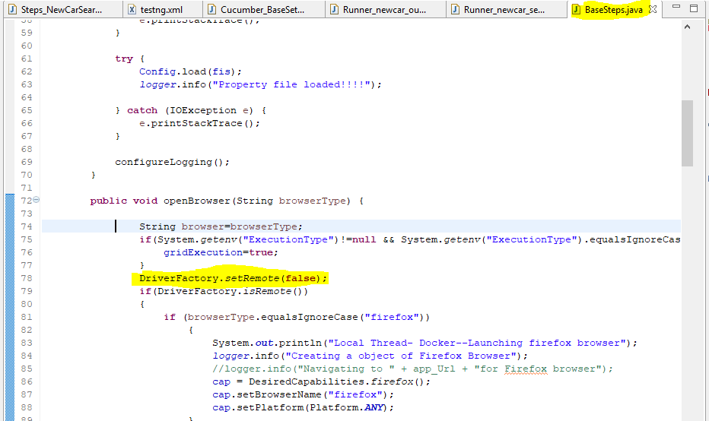

1. Parallel or non-parallel: In order to run the scripts parallel, then we have to define tests in ‘testng.xml’ the scripts will run parallel other they will not. Look at the following example:

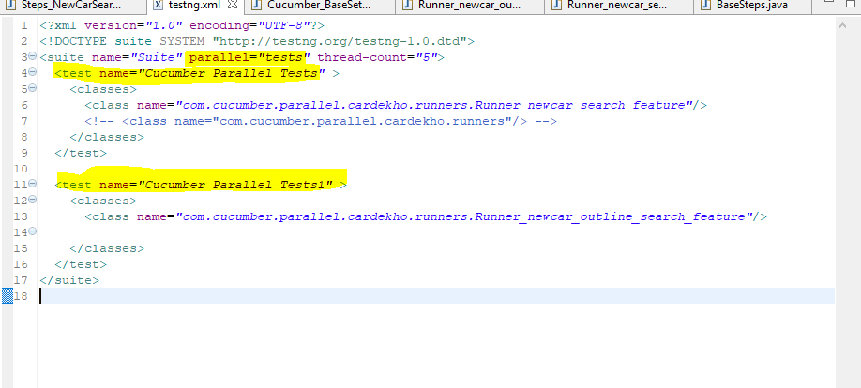

If one of tests are excluded from above file, that means if we have only one test in above file, then the scripts inside the classes will run sequentially i.e. one by one. So, in order to achieve parallelism, we have define multiple tests in above ‘testng.xml’ file.